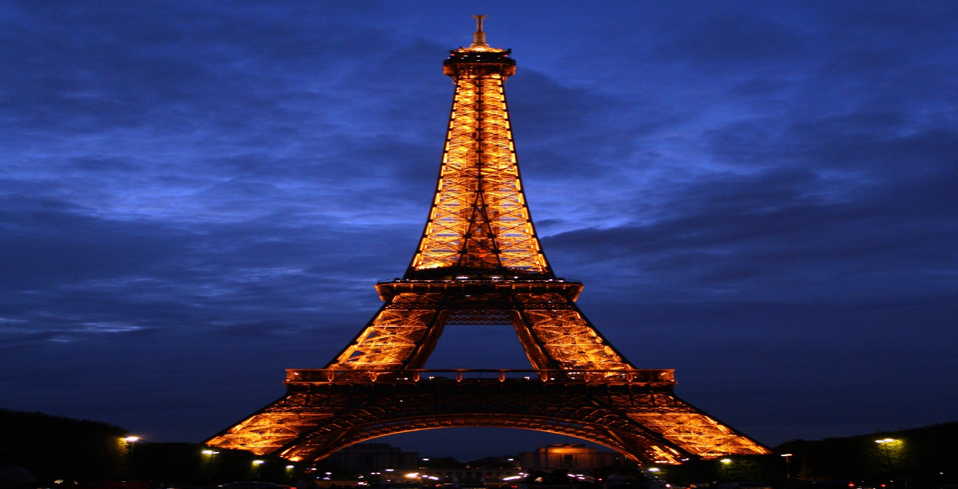**Eiffel Tower**

The **Eiffel Tower**  is a [wrought-iron](https://en.wikipedia.org/wiki/Wrought-iron) [lattice tower](https://en.wikipedia.org/wiki/Lattice_tower) on the [Champ de Mars](https://en.wikipedia.org/wiki/Champ_de_Mars) in [Paris](https://en.wikipedia.org/wiki/Paris), France. It is named after the engineer [Gustave Eiffel](https://en.wikipedia.org/wiki/Gustave_Eiffel), whose company designed and built the tower from 1887 to 1889.

Locally nicknamed "*La dame de fer*" (French for "Iron Lady"), it was constructed as the centerpiece of the [1889 World's Fair](https://en.wikipedia.org/wiki/Exposition_Universelle_(1889)), and to crown the centennial anniversary of the [French Revolution](https://en.wikipedia.org/wiki/French_Revolution). Although initially criticised by some of France's leading artists and intellectuals for its design, it has since become a global [cultural icon](https://en.wikipedia.org/wiki/Cultural_icon) of France and one of the most recognisable structures in the world.[[5]](https://en.wikipedia.org/wiki/Eiffel_Tower#cite_note-Key_figures-5) The tower received 5,889,000 visitors in 2022.[[6]](https://en.wikipedia.org/wiki/Eiffel_Tower#cite_note-6) The Eiffel Tower is the most visited monument with an entrance fee in the world:[[7]](https://en.wikipedia.org/wiki/Eiffel_Tower" \l "cite_note-:0-7) 6.91 million people ascended it in 2015. It was designated a [*monument historique*](https://en.wikipedia.org/wiki/Monument_historique) in 1964, and was named part of a [UNESCO](https://en.wikipedia.org/wiki/UNESCO) [World Heritage Site](https://en.wikipedia.org/wiki/World_Heritage_Site) ("Paris, Banks of the Seine") in 1991.[[8]](https://en.wikipedia.org/wiki/Eiffel_Tower#cite_note-8)

The tower is 330 metres (1,083 ft) tall,[[9]](https://en.wikipedia.org/wiki/Eiffel_Tower#cite_note-9) about the same height as an 81-storey building, and the [tallest structure in Paris](https://en.wikipedia.org/wiki/List_of_tallest_buildings_and_structures_in_the_Paris_region). Its base is square, measuring 125 metres (410 ft) on each side. During its construction, the Eiffel Tower surpassed the [Washington Monument](https://en.wikipedia.org/wiki/Washington_Monument) to become the [tallest human-made structure](https://en.wikipedia.org/wiki/List_of_tallest_freestanding_structures_in_the_world#Timeline_of_world's_tallest_freestanding_structures) in the world, a title it held for 41 years until the [Chrysler Building](https://en.wikipedia.org/wiki/Chrysler_Building) in New York City was finished in 1930. It was the first structure in the world to surpass both the 200-metre and 300-metre mark in height. Due to the addition of a broadcasting [aerial](https://en.wikipedia.org/wiki/Aerial_(radio)) at the top of the tower in 1957, it is now taller than the Chrysler Building by 5.2 metres (17 ft). Excluding transmitters, the Eiffel Tower is the [second tallest free-standing structure in France](https://en.wikipedia.org/wiki/List_of_tallest_structures_in_France) after the [Millau Viaduct](https://en.wikipedia.org/wiki/Millau_Viaduct).

The tower has three levels for visitors, with restaurants on the first and second levels. The top level's upper platform is 276 m (906 ft) above the ground—the highest [observation deck](https://en.wikipedia.org/wiki/Observation_deck) accessible to the public in the [European Union](https://en.wikipedia.org/wiki/European_Union). Tickets can be purchased to ascend by stairs or [lift](https://en.wikipedia.org/wiki/Elevator) to the first and second levels. The climb from ground level to the first level is over 300 steps, as is the climb from the first level to the second, making the entire ascent a 600 step climb. Although there is a staircase to the top level, it is usually accessible only by lift. On this top, third level is a private apartment built for Gustave Eiffel's personal use. He decorated it with furniture by Jean Lachaise and invited friends such as [Thomas Edison](https://en.wikipedia.org/wiki/Thomas_Edison).

**History**

**Origin**

The design of the Eiffel Tower is attributed to [Maurice Koechlin](https://en.wikipedia.org/wiki/Maurice_Koechlin) and [Émile Nouguier](https://en.wikipedia.org/wiki/%C3%89mile_Nouguier" \o "Émile Nouguier), two senior engineers working for the [Compagnie des Établissements Eiffel](https://en.wikipedia.org/wiki/Gustave_Eiffel" \o "Gustave Eiffel). It was envisioned after discussion about a suitable centerpiece for the proposed [1889 Exposition Universelle](https://en.wikipedia.org/wiki/Exposition_Universelle_(1889)), a [world's fair](https://en.wikipedia.org/wiki/World%27s_fair) to celebrate the centennial of the [French Revolution](https://en.wikipedia.org/wiki/French_Revolution). In May 1884, working at home, Koechlin made a sketch of their idea, described by him as "a great pylon, consisting of four lattice girders standing apart at the base and coming together at the top, joined together by metal [trusses](https://en.wikipedia.org/wiki/Truss) at regular intervals".[[10]](https://en.wikipedia.org/wiki/Eiffel_Tower#cite_note-10) Eiffel initially showed little enthusiasm, but he did approve further study, and the two engineers then asked [Stephen Sauvestre](https://en.wikipedia.org/wiki/Stephen_Sauvestre), the head of the company's architectural department, to contribute to the design. Sauvestre added decorative arches to the base of the tower, a glass pavilion to the first level, and other embellishments.